FOR IMMEDIATE RELEASE

ANIME EXPO’S VOICE CAST AUDITIONS FOR JAPANESE TV ANIME SERIES "SHIKIZAKURA" - OPEN FOR ENTRIES!
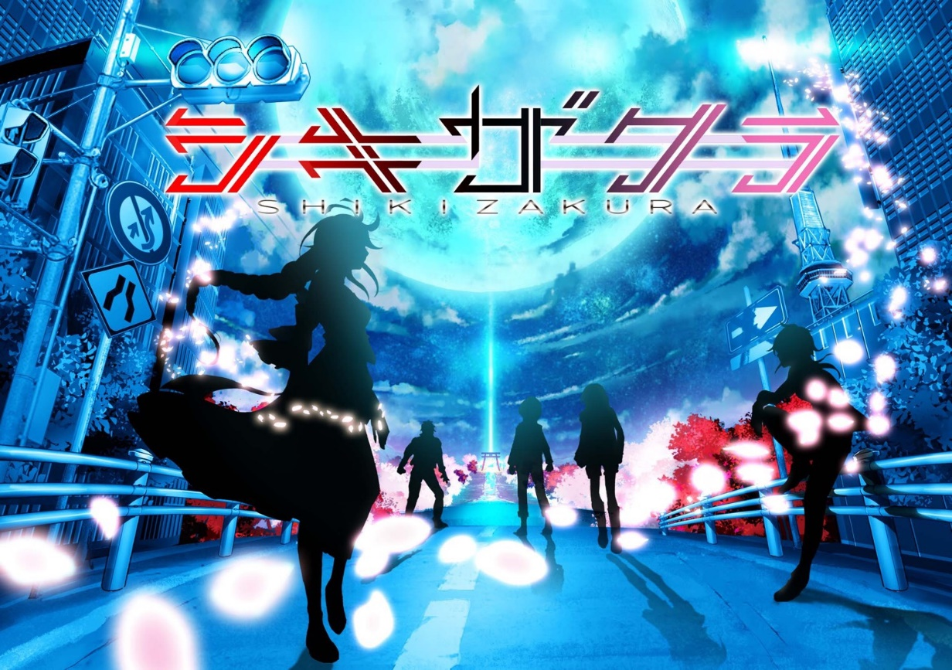

Santa Ana, Calif. — (May 1, 2019) - The Society for the Promotion of Japanese Animation (SPJA) is excited to announce, in conjunction with Chukyo TV, that Anime Expo (AX) 2019 will be the location of voice cast auditions for SHIKIZAKURA, the first-ever TV animation series with 12 episodes created in the Tokai region of Central Japan. The animated series is scheduled to be on-air in 2020.

AX Audition = Japanese Dream

During AX, Japanese TV anime series “SHIKIZAKURA” will have voice cast auditions for an English-speaking role. This is a once-in-a-lifetime chance to become a cast member of a Japanese anime! The winner will be invited to Japan for the voice dubbing, and more! The list of judges is impressive including virtual YouTuber MIYA KIMINO, Director, Shinya Sugai (SUBLIMATION), Sound Director, Takumi Saito (SUBLIMATION) and many more.
To participate, please see the following guidelines.
• QUALIFICATION REQUIREMENTS: Actors must meet all of the items below:
1) Must be over 18 and living in the United States.
2) If selected after First Round, must be able to attend both audition dates at AX19 (Second round: July 4, Final round: July 6).
3) Must be able to travel for three nights and five days to Japan in fall 2019. (Details will be confirmed after the winner is selected.)
4) Must have an AX19 Badge to attend the audition.
FIRST ROUND SCREENING
• APPLICATION PERIOD
April 22 - May 22, until 5pm (PDT)
• HOW TO APPLY
1. Upload a video* on YouTube with #AX_Audition_2019 including all of the items below.
A) Self-introduction.
B) Acting on “happiness”, such as being able to visit Japan or meeting your famous celebrity.
C) Acting on “fear”, such as freaking out after encountering an odd-looking villain.
D) Acting on your free setting.
*Each item needs to be within 30 seconds, in total no more than 2 minutes.
*All item needs to be in a single video.

*The brief character setting is an anime fan who loves Japanese anime and comes to Aichi-Prefecture in JAPAN.

2. Fill out the form with accurate information. ★
https://www.ctv.co.jp/shikizakura/index_english_audition.html

• SELECTION CRITERIA
Voice Quality: 30%, Acting: 30%, Applicant’s Individuality: 40%

• WINNER’S RECEIVE
Date of Travel: Fall 2019 (Confirmed after winner’s selection)
Days: 3 nights and 5 days
• Anime dubbing in Japan
• Round-trip economy class flight ticket from LA to Nagoya and accommodation fee for a single person
• Touring within Aichi prefecture (scheduled to include the locations featured in SHIKIZAKURA)

• RESULT ANNOUNCEMENT
Those who passed the initial Round One screening will receive and email by June 14.

• JUDGES
Director: Shinya Sugai (SUBLIMATION)
Sound Director: Takumi Saito (SUBLIMATION)
Virtual YouTuber MIYA KIMINO, and more.

About SUBLIMATION
The production company of the “SHIKIZAKURA” series, known for their 3DCG works such as “Love Live!” series, “Tokyo Ghoul” series, “Psycho-Pass” series, “GHOST IN THE SHELL: ARISE” series and “EVANGELION:3.0 YOU CAN (NOT) REDO.”

■“SHIKIZAKURA” Production Committee
CHUKYO TV. BROADCASTING CO.,LTD. (President ：Nobuo Komatsu)
Sublimation Inc. (CEO：Atsushi Koishikawa)
tamakoshi Co.,Ltd. (CEO：Kodo Takagi)
Nakanihon KOGYO Co.,Ltd. (CEO：Toru Hattori)
K&K DESIGN CO., LTD. (CEO：Shuji Kikkawa)

■Outline
Title: SHIKIZAKURA
TV series 12 episodes: 30 minutes length
Genre: Near-Future Science Fiction Action Drama
Animation Technique: Hybrid (2D & 3DCG)
Production Studio: SUBLIMATION
Director: Shinya Sugai
Character Design: K&K Design
Completion Date: 2020
Official Site: https://www.ctv.co.jp/shikizakura/

■ANIME EXPO
Date: July 4 - 7, 2019
Venue: Los Angeles Convention Center
Organizer：Society for the Promotion of Japanese Animation (SPJA)
* ANIME EXPO is the largest North American anime convention gathering more than 350,000 people every year.
Official Site: http://www.anime-expo.org/
About Anime Expo
Anime Expo (AX) brings together fans and industry from Japan, the US, and all over the world for the largest celebration of Japanese pop culture in North America. Taking place every year since 1992, Anime Expo features the best in Japanese entertainment, music, fashion, and video games. For more information, visit www.anime-expo.org.

About SPJA
SPJA is a non-profit organization dedicated to popularize and educate the American public about Japanese entertainment and pop culture, as well as provide a forum to facilitate communication between professionals and fans. For more information, please visit www.spja.org.

MIYA KIMINO
She is MANEKI-NEKO（beckoning cat）who
descended on earth to share Japanese culture with
the world and acts as a bridge between Japan
and other countries to bring prosperity to the world.

◇Official site：https://japanese-hanjo.tv
◇YouTube Channel:
https://www.youtube.com/channel/UCg8TPE5nLLOqlNnBivmQwww

For Further Information:
Chukyo TV
Business Promotion Division
Masao Kawahara
kawahara@ctv.co.jp

###
